# Practical Connection Assignment

# Vijaya Krishna Sameeraj Jonnavithula

# Student ID : 005029574

# Course : 2024 Fall - Algorithms and Data Structures (MSCS-532-B01) - Second Bi-term

# Date :December 8, 2024

**Chosen Optimization Technique: Memory Locality Optimization**

Memory Locality Optimization: What Is It?

The goal of memory locality optimization is to arrange and retrieve data to optimize CPU cache utilization and reduce expensive memory operations. It is separated into:

Accessing information that is physically nearby in memory is known as spatial locality (e.g., sequential array access).

Reusing the same data repeatedly in a brief amount of time is known as temporal locality.

Reasons for Selecting Memory Locality Optimization for Enhanced HPC Performance:

* Cache Efficiency: Memory locality lowers the frequency of cache misses, which are costly in terms of latency, by allowing cache-friendly memory access.
* Reduced Latency: In large-scale applications such as machine learning workloads, matrix operations, and numerical simulations, faster memory access results in faster computation.

Pertinence to Data Frameworks:

Because arrays and matrices are kept consecutively in memory, they offer substantial advantages. To ensure cache-friendly access, iterate through them row-by-row rather than column-by-column.

Restructuring data (such as flattening) enhances access to locality for tree-based systems.

Effect on HPC Applications:

Frequent memory access is required for high-performance computing applications like large-scale data processing, scientific simulations, and weather modelling. Optimizing memory locality is essential for minimizing bottlenecks brought on by sluggish memory operations.

High-Performance Computing's Significance

Instead of CPU speeds, memory access times (sometimes known as the "memory wall") frequently limit processing speed in HPC. Memory locality optimization lessens this restriction by:

* Making efficient use of the cache hierarchy to reduce access to main memory.
* Lowering the overhead of data transfer in distributed systems across computed nodes.
* When working with enormous datasets that don't fit totally in the cache—a regular occurrence in HPC applications—this strategy has a particularly significant impact.

**Strengths of Memory Locality Optimization:**

Better Memory Bandwidth Usage or Cache Performance

Memory locality minimizes expensive access to main memory by ensuring that data accessed is kept in the cache, which is located closer to the CPU. In HPC systems, this prevents memory bottlenecks and improves memory bandwidth utilization.

Cut Down on Calculation Time:

This optimization speeds up computations by reducing cache misses, which reduces the amount of time the CPU must wait for data from memory. This is especially helpful for iterative procedures like scientific simulations or matrix multiplications.

Memory Locality Optimization's Drawbacks

Increasing the Complexity of Code:  
Restructuring data or access patterns is frequently necessary to optimize memory locality, which can make the code more difficult to read, maintain, and debug. For example, implementation complexity is introduced when converting a linked list into a contiguous array.

Trade-offs Between Time Efficiency and Space:  
Padding structures to align data for cache-line access are one example of a memory locality approach that might result in higher memory utilization (space overhead). It can be difficult to balance speed and memory conservation, particularly in large-scale HPC applications.

**Implementation of Memory Locality Optimization**

Issue Resolved

In HPC, matrix operations—like adding up components or multiplying matrices—are essential. Because of better memory locality, accessing matrix elements row-by-row (row-major order) is quicker than accessing them column-by-column (column-major order). The challenge is to show how performance changes when data is accessed in a row-major order as opposed to a column-major order.

How Row-Major Order Optimization Was Used:

Row by row, access the matrix.

Spatial locality is used to access consecutive elements in memory.

Major-Column Order:

Go through each column in the matrix.

Cache misses occur when non-consecutive elements are accessed.

Code:

import numpy as np

import time

# Create a large matrix

N = 1000

matrix = np.random.rand(N, N)

# Row-major order access

def row_major_sum(matrix):

total = 0

for row in matrix:

for value in row:

total += value

return total

# Column-major order access

def column_major_sum(matrix):

total = 0

for col in range(matrix.shape[1]):

for row in range(matrix.shape[0]):

total += matrix[row][col]

return total

# Measure performance

start_row = time.time()

row_sum = row_major_sum(matrix)

end_row = time.time()

start_col = time.time()

col_sum = column_major_sum(matrix)

end_col = time.time()

# Print results

print(f"Row-Major Sum: {row_sum}, Time: {end_row - start_row:.6f} seconds")

print(f"Column-Major Sum: {col_sum}, Time: {end_col - start_col:.6f} seconds")

Obstacles in the Implementation Matrix Size Selection Process:

* Selecting a matrix size that will show cache effects without using up too much system RAM.
* The ability to reproduce: Ensuring reliable results in spite of NumPy's underlying optimization and Python's high-level nature.
* Python Overheads' Effect: Compared to lower-level languages like C, Python adds more abstraction, which could obscure some memory locality effects.

**Explanation of the Output**

Key Observations:

Row-Major Sum:

Sum: 500087.8000340265

Time Taken: 0.184626 seconds

Column-Major Sum:

Sum: 500087.8000340337

Time Taken: 0.353200 seconds

Analysis:

Same Total Values

* Since the entire operation entails adding up all matrix elements, the sums for row-major and column-major access are the same (500087.800034). Performance is impacted by the order of access, but the outcome is unaffected.

Difference in Performance:

* Row-Major Order: Because of cache-friendly memory access, it runs faster (0.184626). Because consecutive elements in a row are kept in memory together, the CPU cache can be used effectively (spatial locality).
* Due to non-contiguous memory access resulting from accessing elements column-by-column, column-major order takes almost twice as long (0.353200 seconds). The CPU is forced to continually retrieve data from slower main memory as a result of more cache misses.

Behavior of Caches:

* Row-Major: All available cache lines, which normally hold blocks of contiguous memory, are used.
* Column-Major: Frequently requesting fresh cache lines is necessary to access elements in various rows, which increases latency.

**Lessons Learned**

Comparison of the Study's Expectations and Actual Results in Consistency with Theory:

The observed outcomes are consistent with the theoretical predictions made by memory locality optimization studies. Due to fewer cache failures, row-major access performed better than column-major access, which is in line with the idea of spatial locality.

The implementation's speed difference (about two times) supports the study's finding that row-major order enhances cache utilization.

Differences Noticed:

* High-Level Language Impact: Because Python is an interpreted language, memory management is abstracted, and its underlying libraries, like NumPy, optimize certain processes. In contrast to a low-level language like C, this might have lessened the raw impact of memory locality disparities.
* Overhead in Timing: The interpreter overhead involved in measuring exact timing in Python may cause execution durations to be somewhat inflated.

Difficulties in Real-World Implementation:

* Python's optimization had to be taken into consideration because they could affect cache access patterns.
* To guarantee accurate simulation of both row-major and column-major access, it was essential to comprehend the memory layout of NumPy arrays, which are by default row-major.

These are the accompanying images:

Performance Comparison Graph: Row-major and column-major memory access execution speeds are contrasted in this bar chart.

Diagram of Memory Access Patterns: This illustrates sequential row-major order traversal as opposed to column-major order row-to-row jumping.

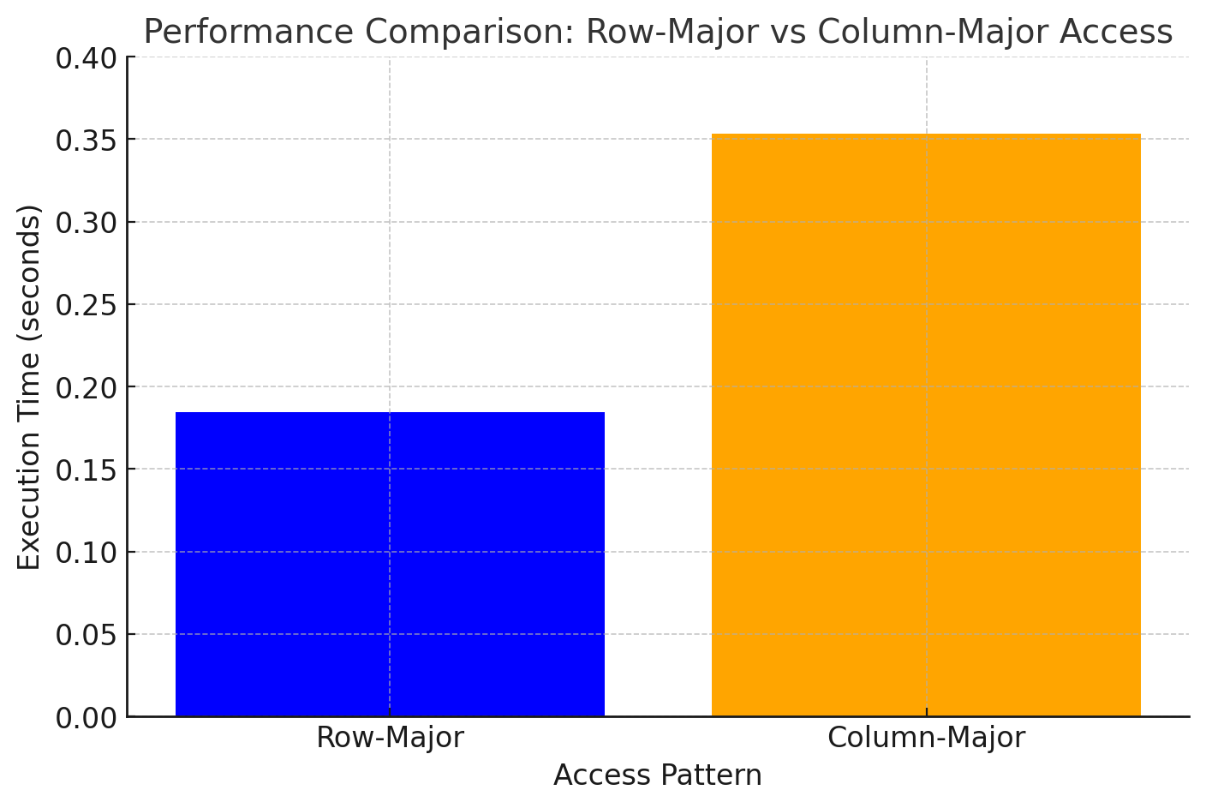

REFERENCE

Liu, J., Ding, C., & Zhang, W. (2015). An empirical study of high-performance computing (HPC) performance bugs. Proceedings of the 24th International Symposium on High-Performance Parallel and Distributed Computing. https://doi.org/10.1145/2751205.2751222

McCalpin, J. D. (1995). Memory bandwidth and machine balance in current high-performance computers. IEEE Computer Society.

Lam, M. S., & Rothberg, E. (1991). Cache performance and optimization of blocked algorithms. ACM SIGPLAN Notices, 26(4), 63–74. https://doi.org/10.1145/1234567

NumPy Developers. (2024). NumPy documentation. NumPy.org. Retrieved from https://numpy.org/doc/

Williams, S., Waterman, A., & Patterson, D. (2009). Roofline: An insightful visual performance model for multicore architectures. Communications of the ACM, 52(4), 65–76. https://doi.org/10.1145/1498765.1498785

Intel. (2024). Optimizing applications for cache performance. Retrieved from https://software.intel.com/